**Detailed Sequence Diagram**

**Use Case: Register**



**Use Case: Make Booking**



**Use Case: Check Vehicle**



**Use Case: Make Invoice**



**Use Case: Assign Job**



**Use Case: View Employee**



**Use Case: View Comment**



**Use Case: View Report**



**Use Case: Add Service**



**Use Case: Update Service**

**UpdateService SSD**



**Use Case: Add Employee**



**Use Case: Add Vehicle**

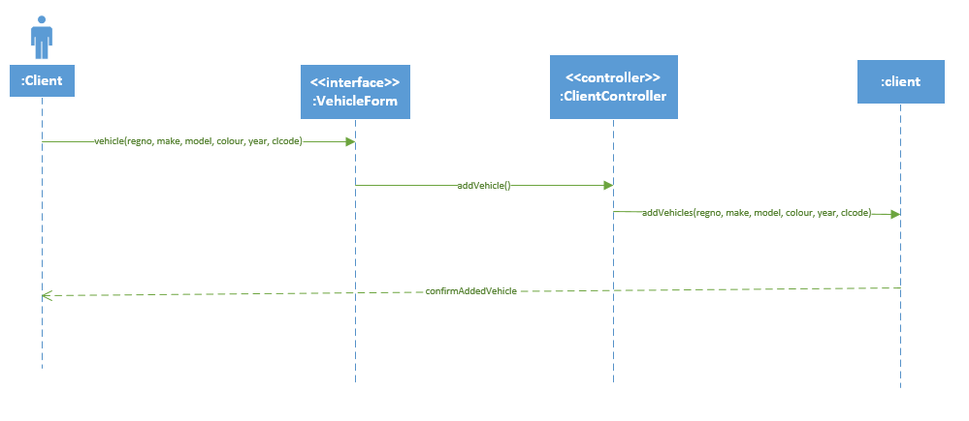

**Use Case: Make Comment**

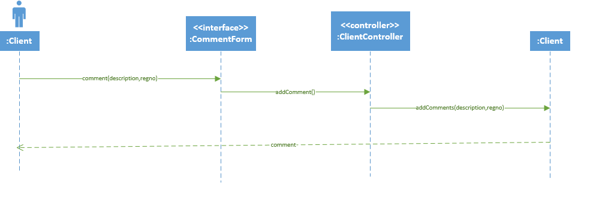

**Use Case: Update Booking**

